## JavaFX 12 and NetBeans（JavaFX12和NetBeans）

This section explains how to use Java 12 and JavaFX 12 from NetBeans. Apache NetBeans 11.0 was used for the following screenshots. It can be downloaded from [here](https://netbeans.apache.org/download/nb110/nb110.html" \t "https://openjfx.io/openjfx-docs/_blank).

Download an appropriate [JDK 12](https://jdk.java.net/11/) for your operating system. Make sure JAVA_HOME is properly set to the Java 12 installation directory.

****Note:****You can set Apache NetBeans to run with this JDK, by editing the etc/netbeans.conf file under the NetBeans installation folder and setting the netbeans_jdkhome property:

netbeans_jdkhome=/path/to/jdk-12

Save and restart NetBeans.

You can create a JavaFX 12 modular or non-modular project and use the IDE tools, Maven or Gradle build tools.

### Non-modular projects

#### IDE

Follow these steps to create a JavaFX non-modular project and use the IDE tools to build it and run it. Alternatively, you can download a similar project from [here](https://github.com/openjfx/samples/blob/master/IDE/NetBeans/Non-Modular/Java" \t "https://openjfx.io/openjfx-docs/_blank).

Download the appropriate [JavaFX SDK](https://gluonhq.com/products/javafx/" \t "https://openjfx.io/openjfx-docs/_blank) for your operating system and unzip it to a desired location, for instance/Users/your-user/Downloads/javafx-sdk-12.

Create a new global Library under Tools -> Libraries -> New Library. Name it JavaFX12 and include the jars under the lib folder from JavaFX 12.

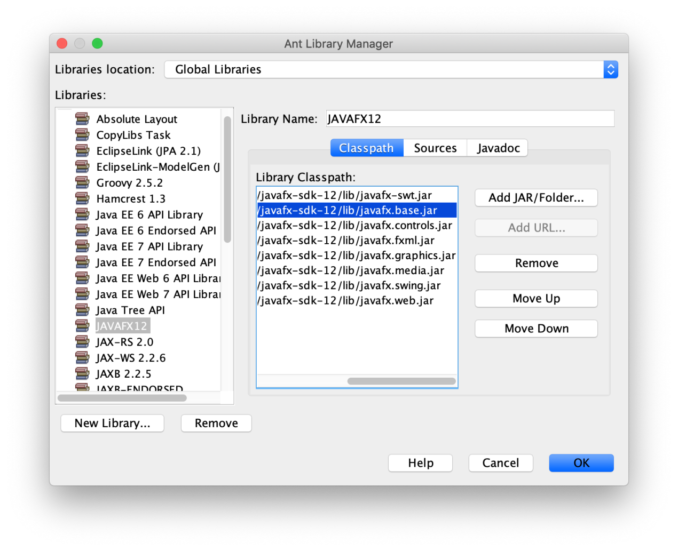

****Note:****Make sure you don't add the src.zip file, as it will cause an exception when running the project.

##### 1. Create a Java project

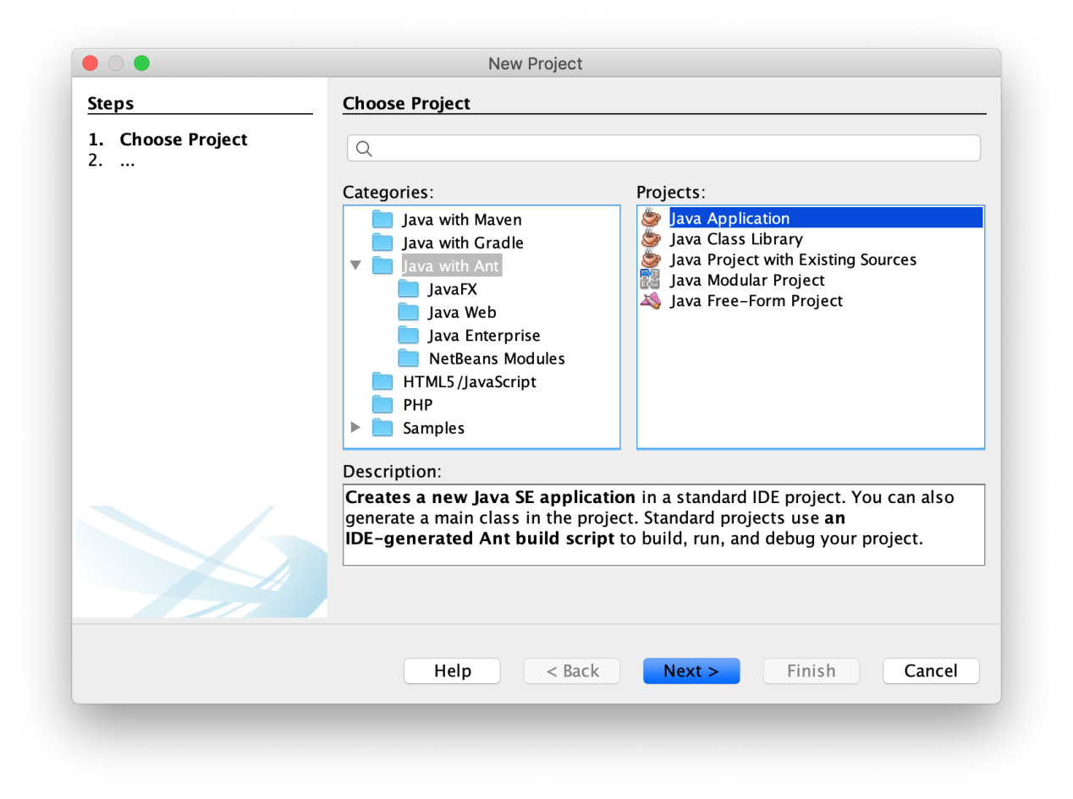

Provide a name to the project, like HelloFX, and a location. An default project will be opened.

****Warning:****Don't try to create a JavaFX project. The JavaFX Ant tasks of the current Apache NetBeans version are not ready for JavaFX 11 yet.

##### 2. Set JDK 12

Make sure your project is configured to run with JDK 12. Go to Properties -> Libraries -> Java Platform, and set it to JDK 12.

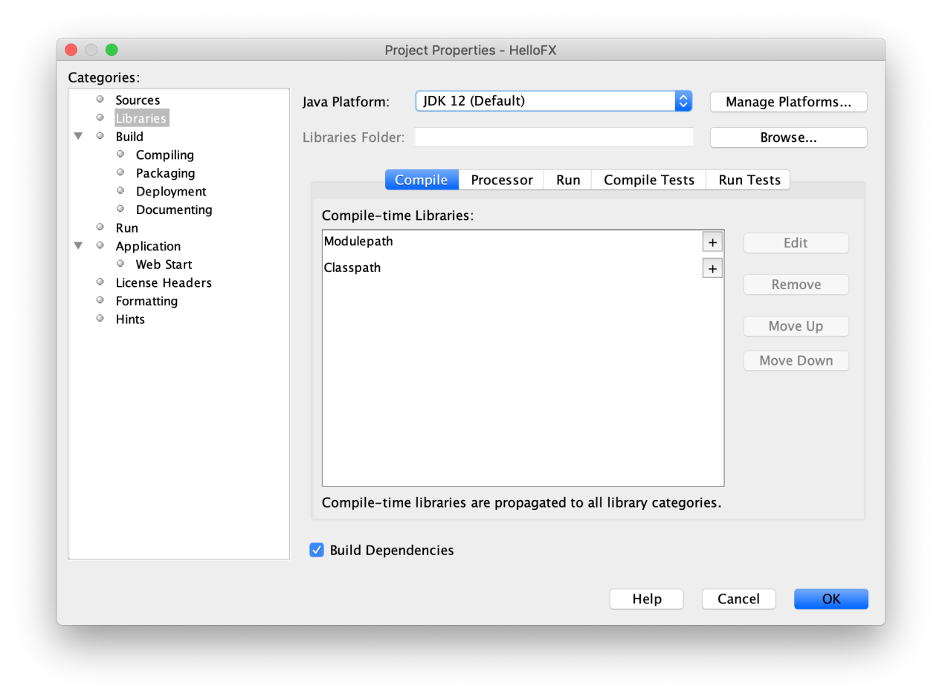

##### 3. Add library

Go to Properties -> Libraries -> Compile -> Class-path -> + -> Add Library  and add the JavaFX12library.

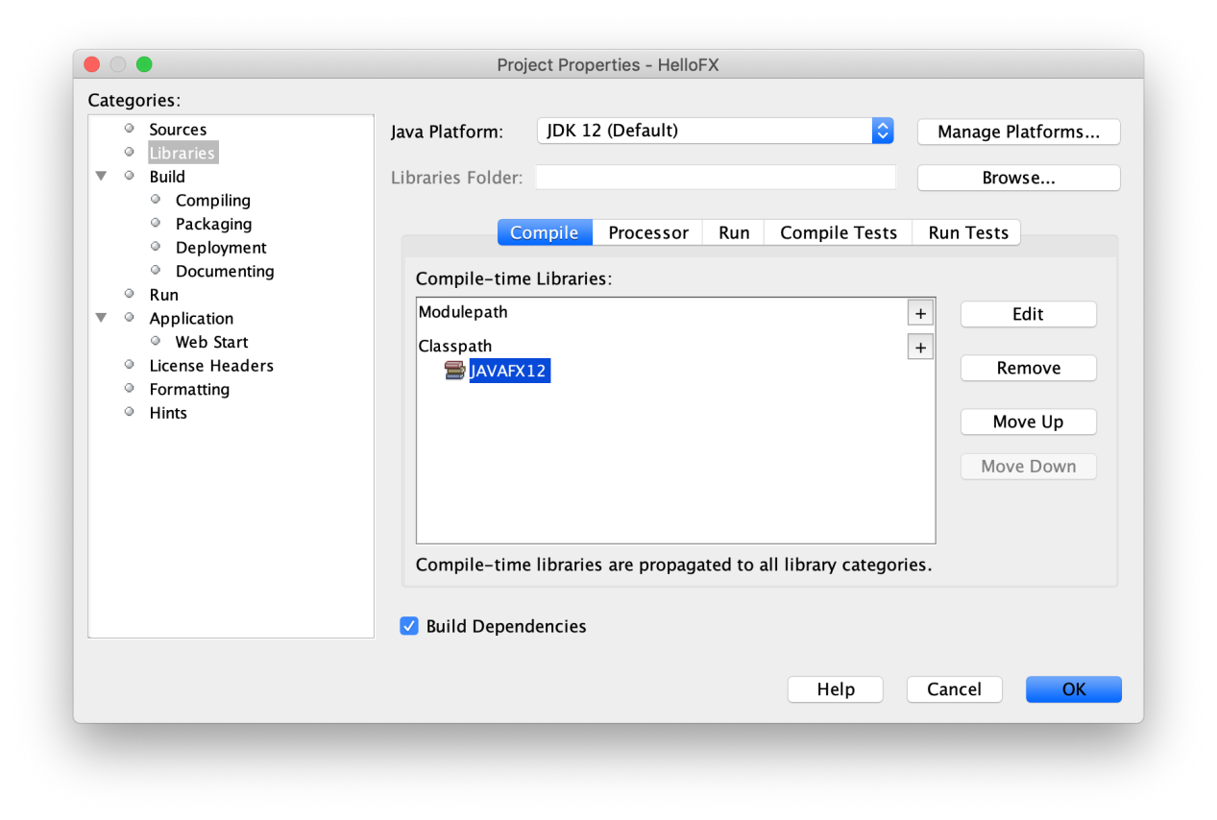

Once the classpath is set, the JavaFX classes will be recognized by the IDE. For instance, you can start extending the Application class:

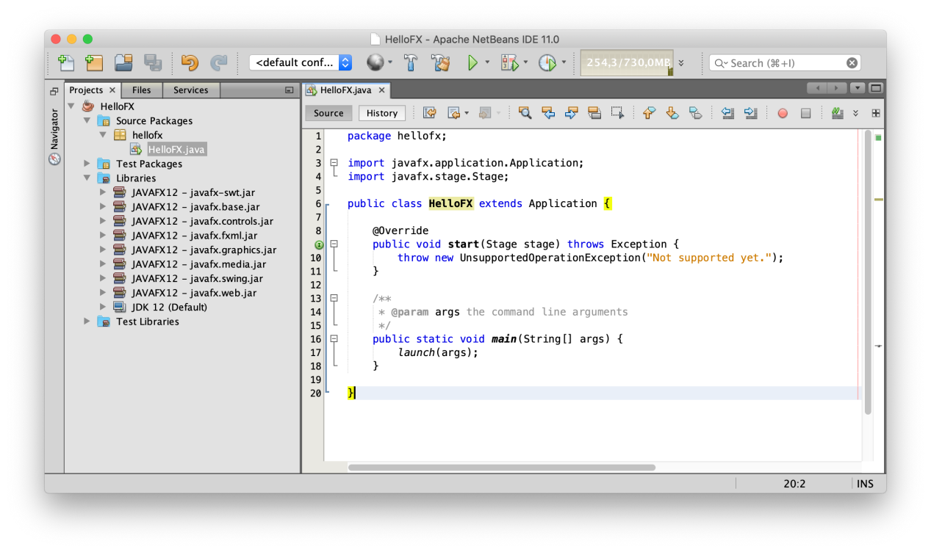

##### 4. Add JavaFX classes

You can add a main class Main, based on this [one](https://github.com/openjfx/samples/blob/master/IDE/NetBeans/Non-Modular/Java/hellofx/src/hellofx/Main.java" \t "https://openjfx.io/openjfx-docs/_blank), with an [FXML](https://github.com/openjfx/samples/blob/master/IDE/NetBeans/Non-Modular/Java/hellofx/src/hellofx/hellofx.fxml" \t "https://openjfx.io/openjfx-docs/_blank) file and a [controller](https://github.com/openjfx/samples/blob/master/IDE/NetBeans/Non-Modular/Java/hellofx/src/hellofx/Controller.java" \t "https://openjfx.io/openjfx-docs/_blank).

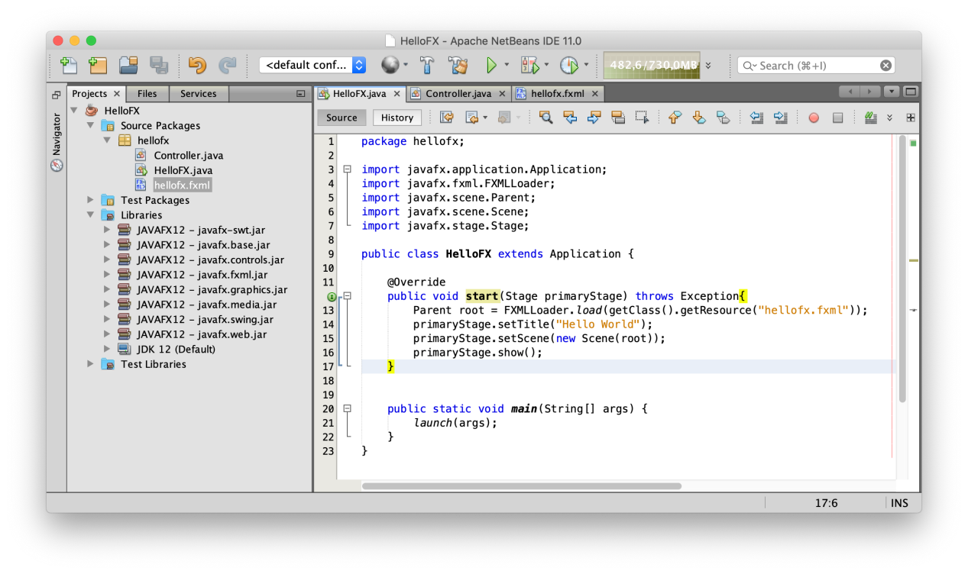

****Warning:****If you run now the project it will compile but you will get this error:

Error: JavaFX runtime components are missing, and are required to run this application

This error is shown since the Java 12 launcher checks if the main class extendsjavafx.application.Application. If that is the case, it is required to have the javafx.graphics module on the module-path.

##### 5. Add VM options

To solve the issue, go to Properties -> Libraries -> Run -> Modulepath -> + -> Add Library  and add the JavaFX12 library.

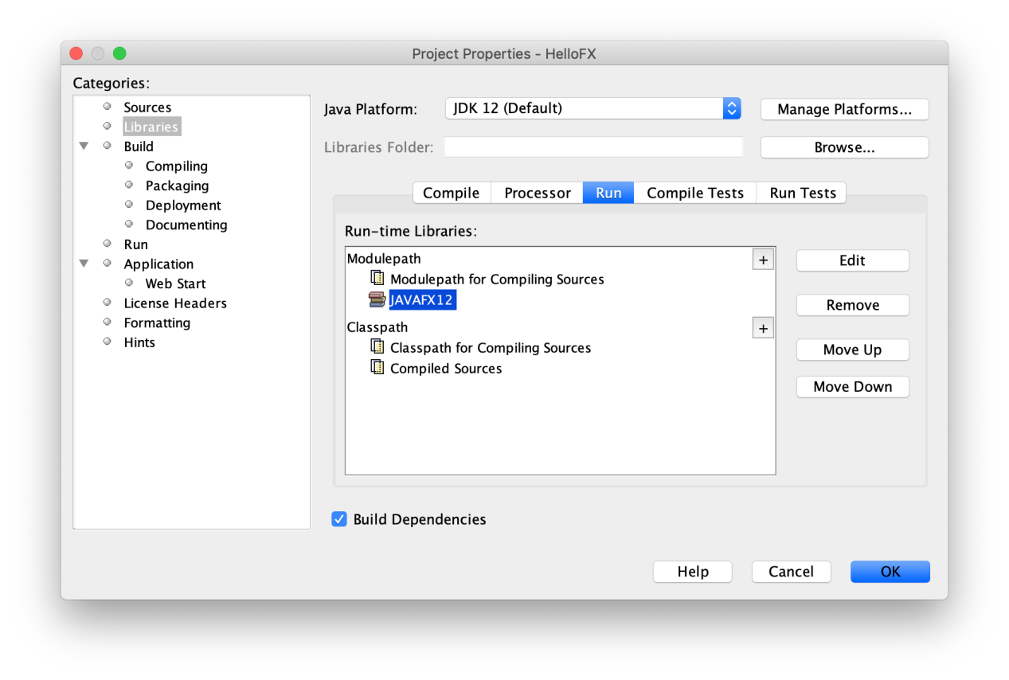

Click OK.

Now go to Properties -> Run and add this VM option:

--add-modules javafx.controls,javafx.fxml

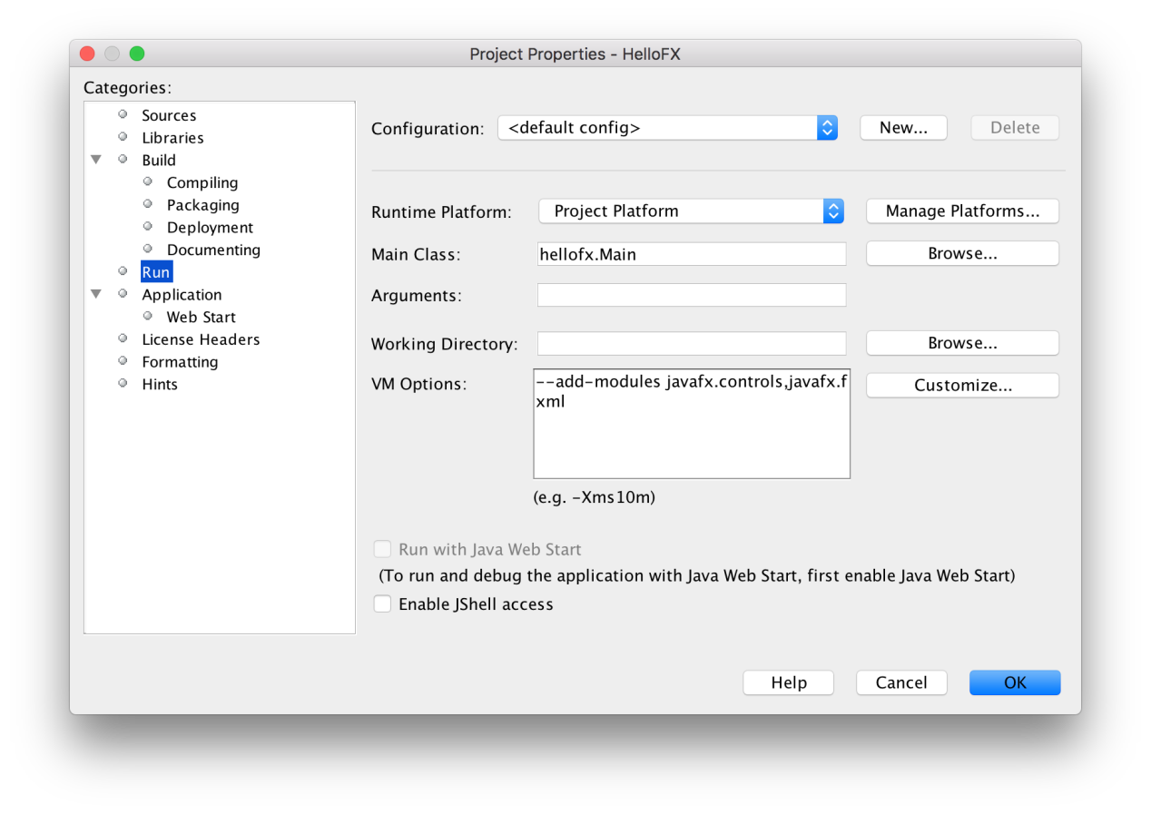

Click apply and close the dialog.

****Note:****If the JavaFX12 library path is added to the --module-path VM option as explained for the rest of the samples in these documents, the project won't run, since NetBeans will override the module-path with an empty path. So that is why it has to be added to the Libraries -> Run -> modulepath options instead.

##### 6. Run the project

Click Run -> Run Project to run the project, now it should work fine.

#### Maven

Follow these steps to create a JavaFX non-modular project and use the Maven tools to build it and run it. Alternatively, you can download a similar project from [here](https://github.com/openjfx/samples/blob/master/IDE/NetBeans/Non-Modular/Maven" \t "https://openjfx.io/openjfx-docs/_blank).

##### 1. Create a Maven project

You can select the Java with Maven -> Project from Archetype project.

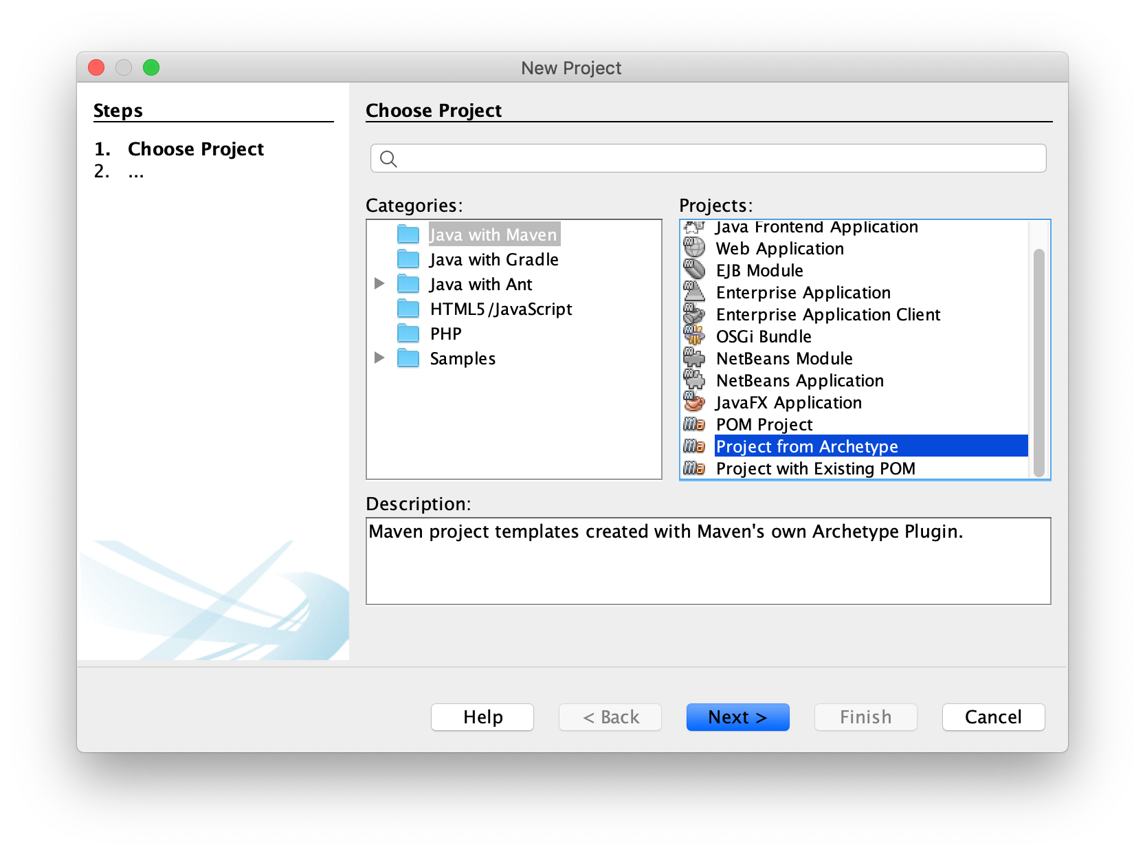

Look for org.openjfx in the search field and select the archetype, between javafx-archetype-fxml or javafx-archetype-simple, based on the use of FXML or not in your project.

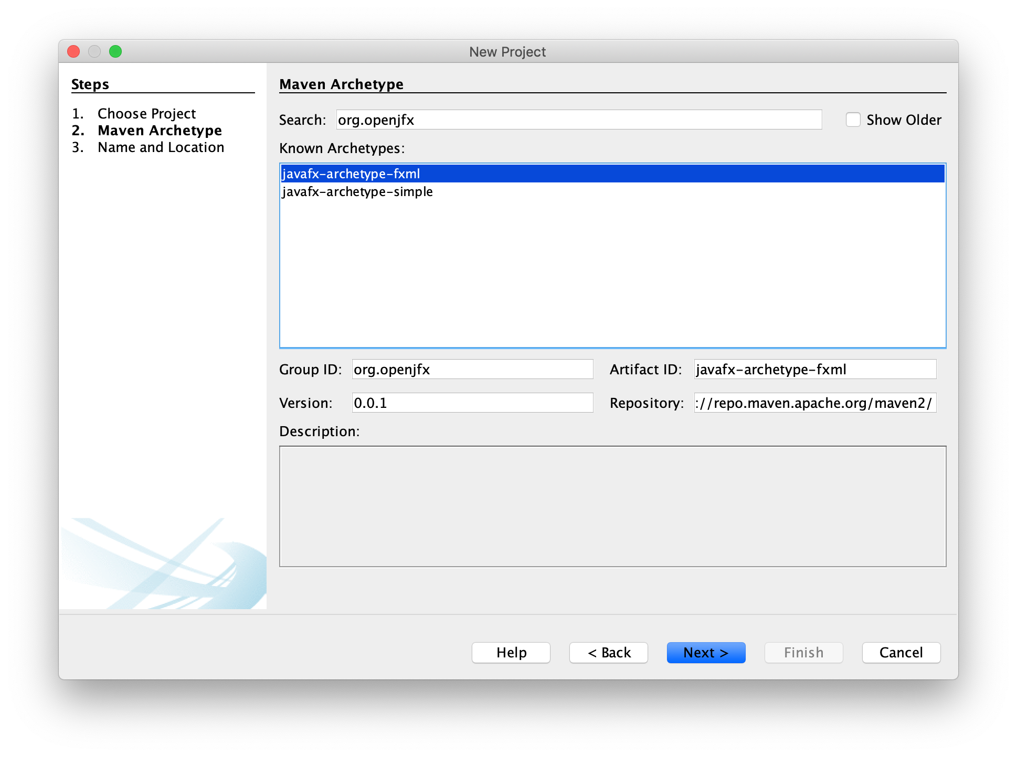

Provide the name of the project, like HelloFX and a location. Provide the groupId, like org.openjfx, the package name, like org.openjfx.hellofx.

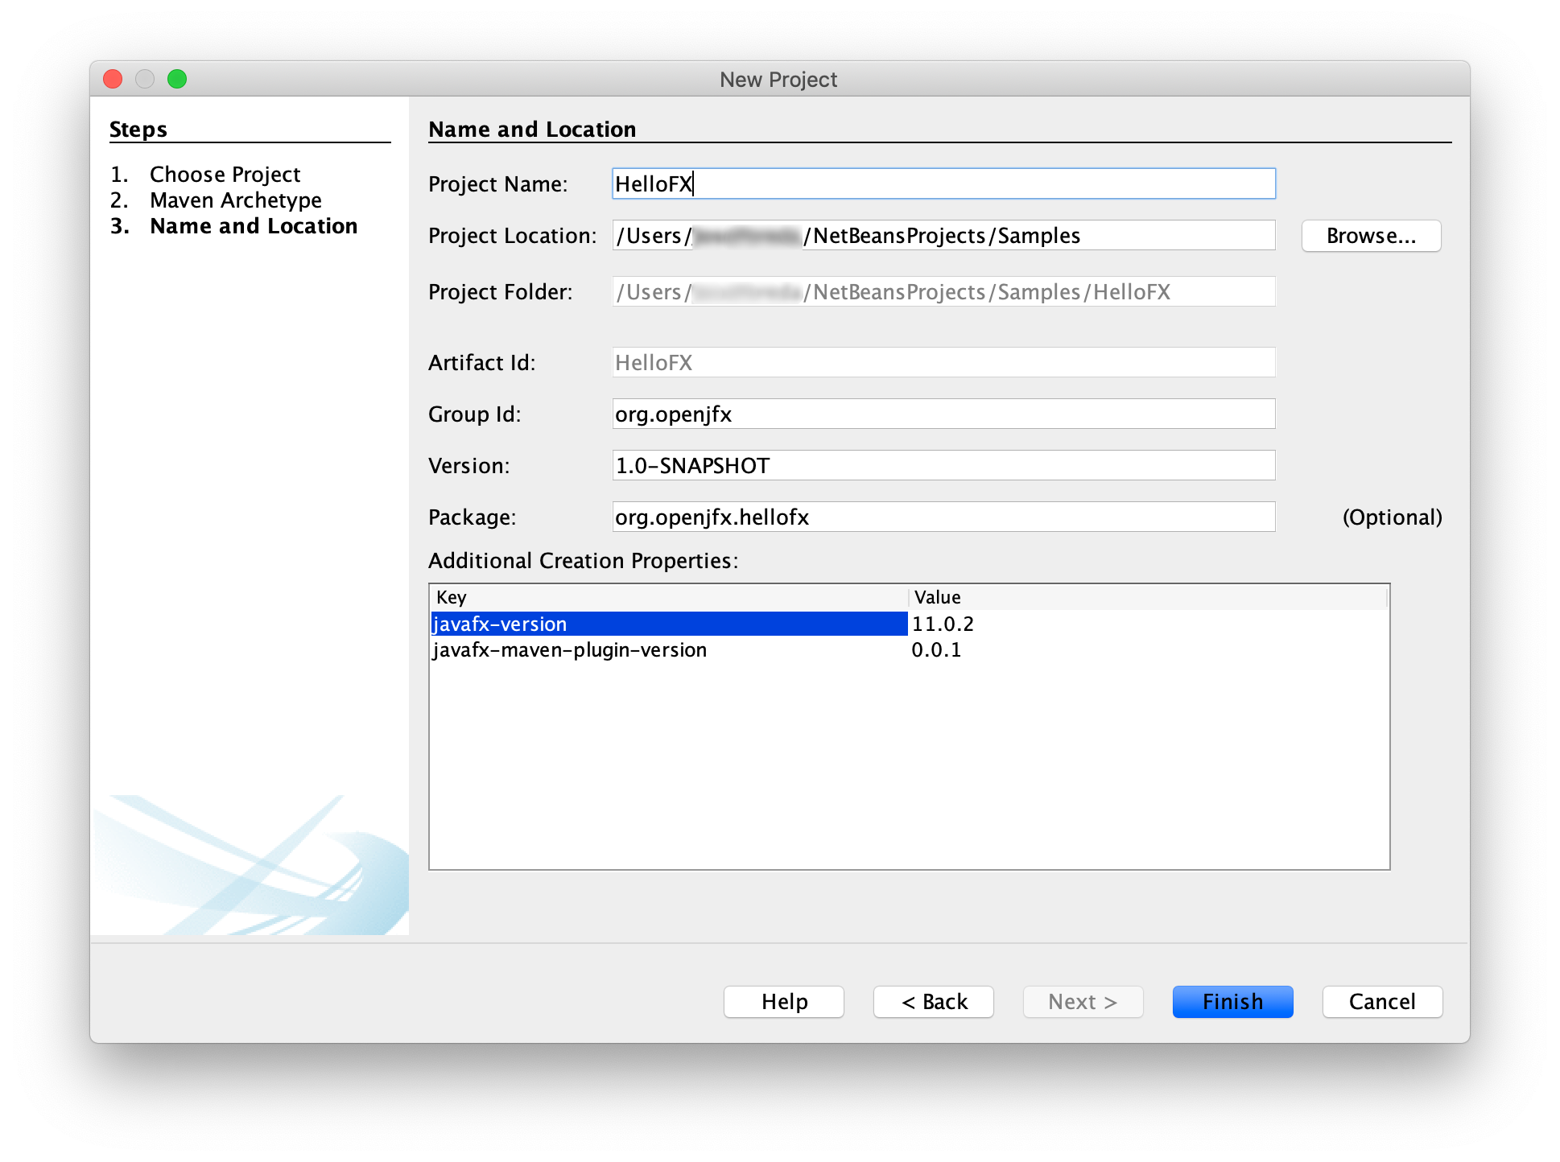

Click finish and the project will be created and opened.

##### 2. Verify the pom

You can find the generated pom file [here](https://github.com/openjfx/samples/blob/master/IDE/NetBeans/Non-Modular/Maven/hellofx/pom.xml" \t "https://openjfx.io/openjfx-docs/_blank).

Verify it includes the javafx.controls and javafx.fxml dependencies, update their version to 12.0.1, and verify it includes the javafx-maven-plugin. Note that Maven manages the required dependencies: it will add javafx.baseand javafx.graphics that are required by javafx.controls and javafx.fxml, but most important, it will add the required classifier based on your platform, downloading the specific platform jars. As for any other maven dependencies, these jars can be found in the local .m2 repository.

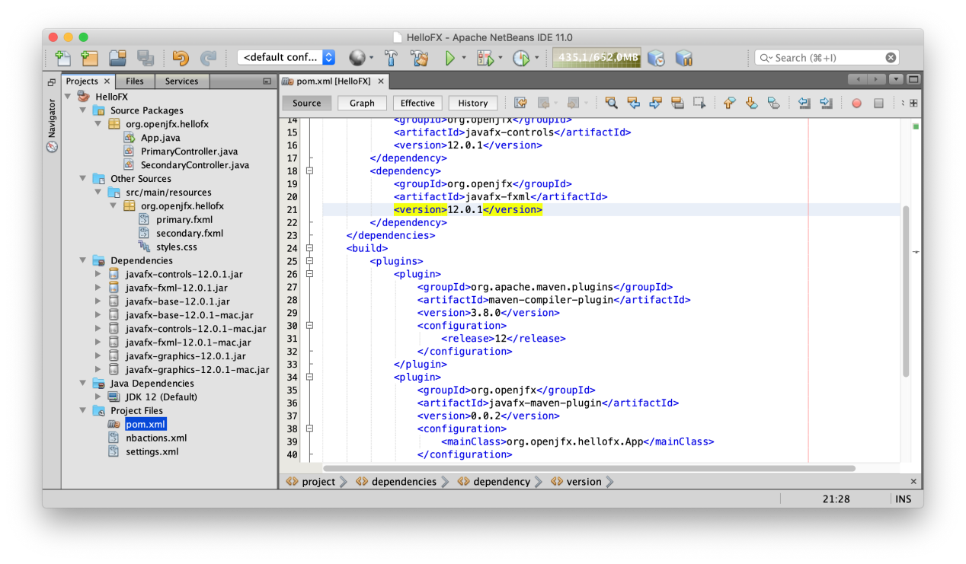

For a non-modular project, you can remove the module-info.java file.

##### 3. Run the project

Before running the project from the Run button, we need to instruct NetBeans to use the javafx plugin instead of the default one. For that, go to Properties -> Actions -> Run project and change the Execute Goals with this:

clean javafx:run

Remove the default Set properties and click OK.

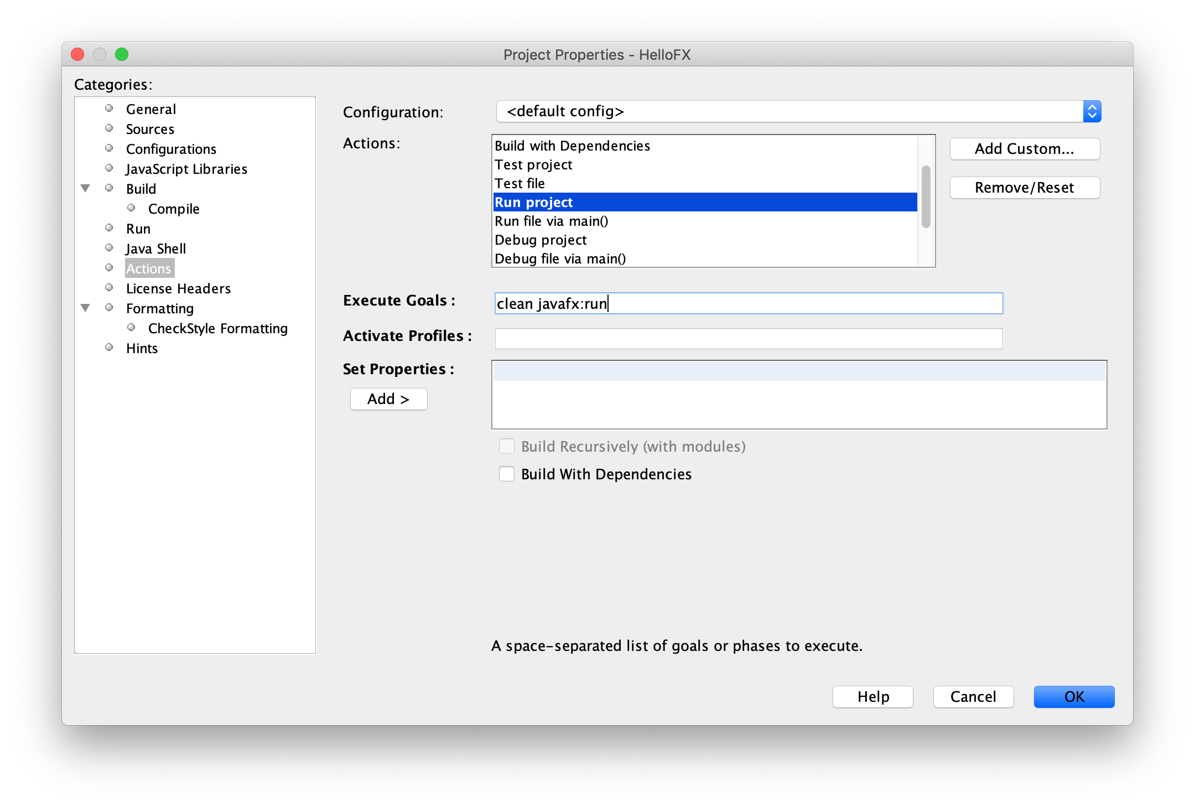

A nbactions.xml file will be created with this configuration.

Click Run -> Run Project to run the project.

****Note:****In case JAVA_HOME is not set to 12, running the project might fail. To avoid it, you can add the correct java command to the javafx-maven-plugin: <configuration><executable>/path/to/jdk-12/bin/java</executable></configuration>.

You can also open a terminal and run mvn clean javafx:run to run the project.

#### Gradle

Follow these steps to create a JavaFX non-modular project and use the Gradle tools to build it and run it. Alternatively, you can download a similar project from [here](https://github.com/openjfx/samples/blob/master/IDE/NetBeans/Non-Modular/Gradle" \t "https://openjfx.io/openjfx-docs/_blank).

Since NetBeans 11, Gradle is supported out of the box, but if you run an older version, you will need the Gradle plugin for NetBeans 2.0.2. You can download it from the GitHub [repository](https://github.com/kelemen/netbeans-gradle-project/releases" \t "https://openjfx.io/openjfx-docs/_blank).

##### 1. Create a Gradle project

Create a Java with Gradle -> Java Application project.

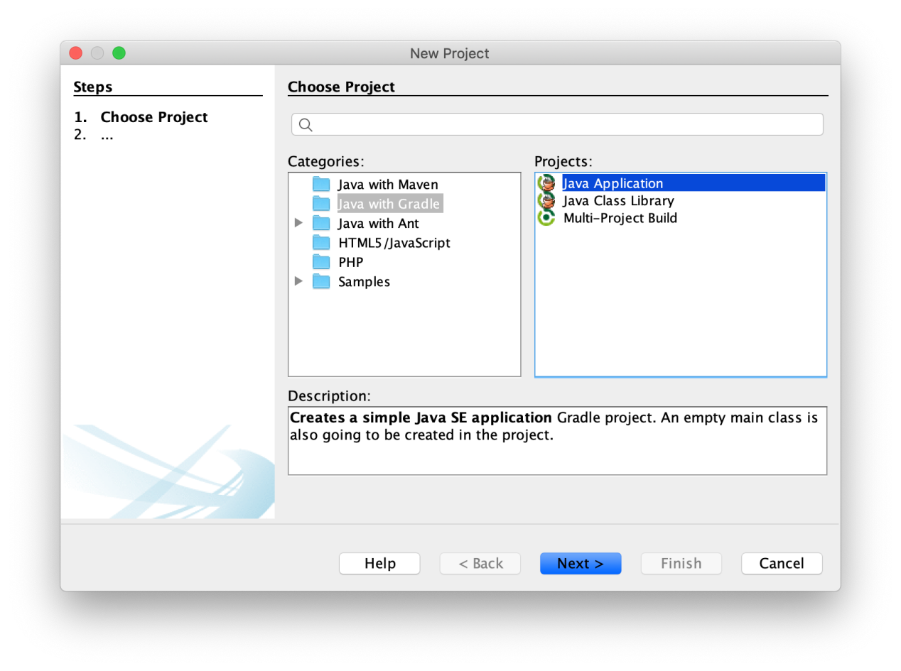

Provide the name of the project, like HelloFX and a location for the project, provide the package name, like org.openjfx and the main class, like MainApp. Finally, select Initialize Gradle Wrapper.

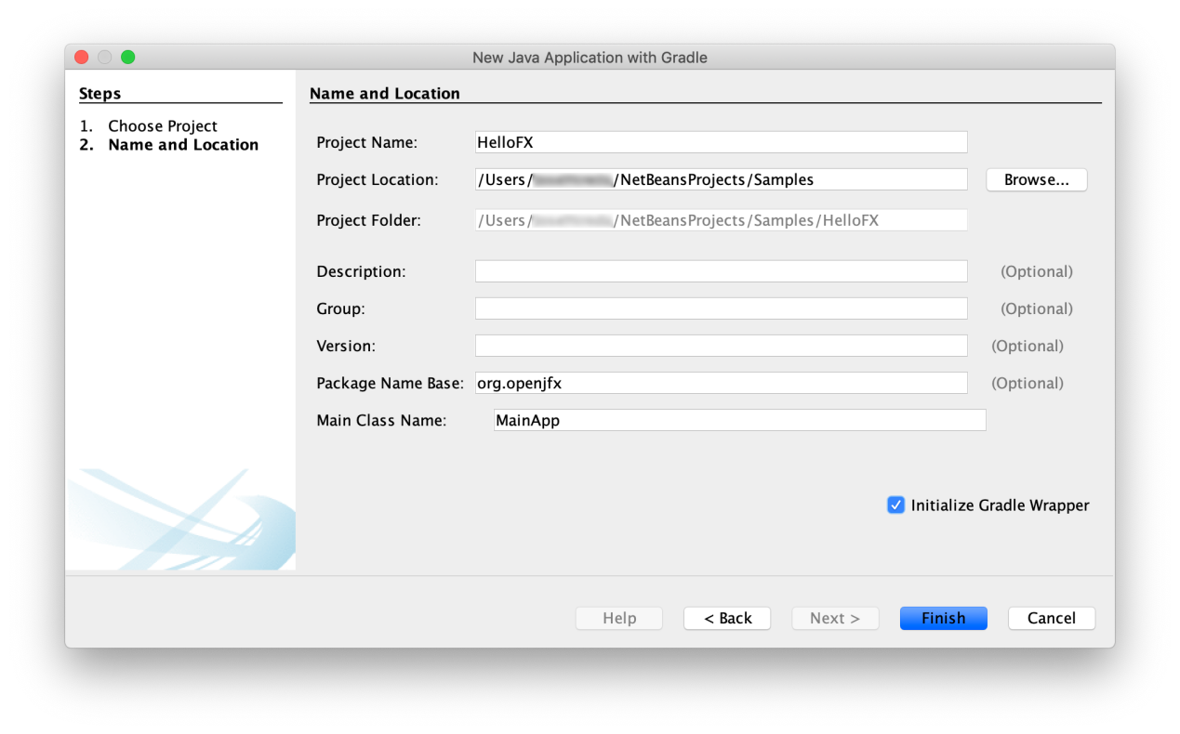

The project is created and opened.

##### 2. Modify the build

Edit the build.gradle file and replace it with this [build](https://github.com/openjfx/samples/blob/master/IDE/NetBeans/Non-Modular/Gradle/hellofx/build.gradle" \t "https://openjfx.io/openjfx-docs/_blank) file.

We can declare the required JavaFX modules in the build.gradle file using the JavaFX gradle plugin:

javafx {

version = "12.0.1"

modules = [ 'javafx.controls', 'javafx.fxml' ]

}

Save the project and you will get the JavaFX dependencies.

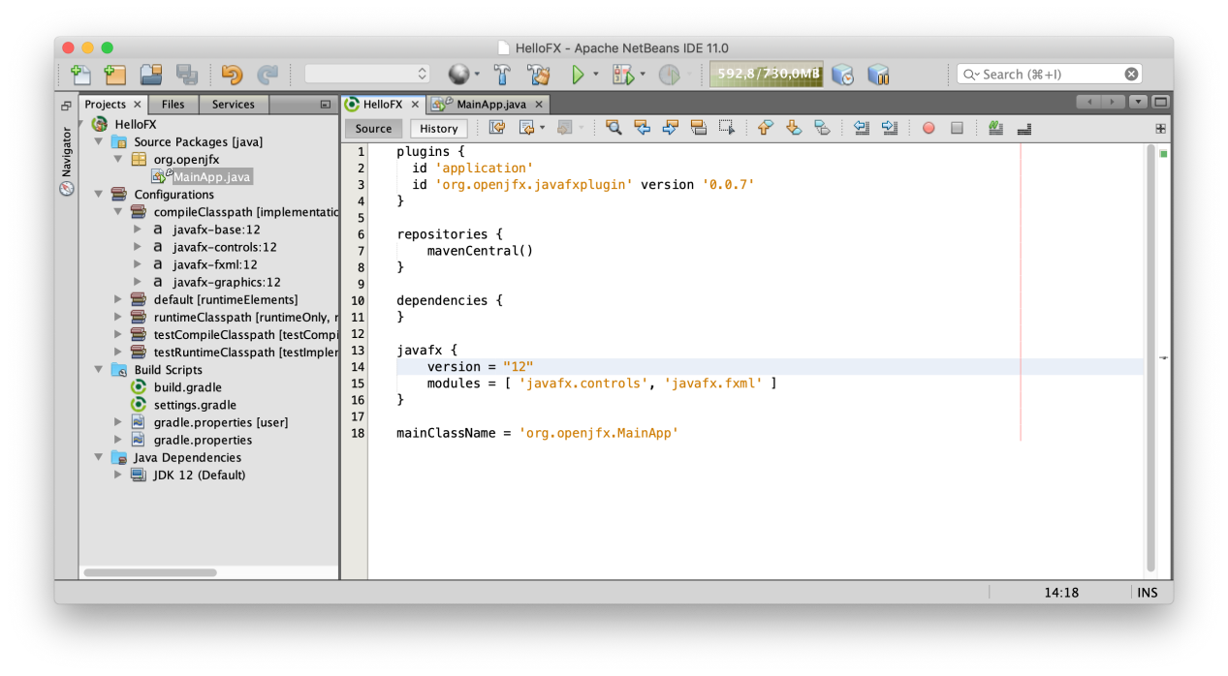

As for any other Gradle dependencies, these jars can be found in the local .gradle repository.

##### 3. Add the source code

Based on this [MainApp](https://github.com/openjfx/samples/blob/master/IDE/NetBeans/Non-Modular/Gradle/hellofx/src/main/java/org/openjfx/MainApp.java" \t "https://openjfx.io/openjfx-docs/_blank) class, add its content to the project main class. Then add the [controller](https://github.com/openjfx/samples/blob/master/IDE/NetBeans/Non-Modular/Gradle/hellofx/src/main/java/org/openjfx/FXMLController.java" \t "https://openjfx.io/openjfx-docs/_blank) and the [FXML](https://github.com/openjfx/samples/blob/master/IDE/NetBeans/Non-Modular/Gradle/hellofx/src/main/resources/org/openjfx/scene.fxml" \t "https://openjfx.io/openjfx-docs/_blank) and and the [css](https://github.com/openjfx/samples/blob/master/IDE/NetBeans/Non-Modular/Gradle/hellofx/src/main/resources/org/openjfx/styles.css" \t "https://openjfx.io/openjfx-docs/_blank) files.

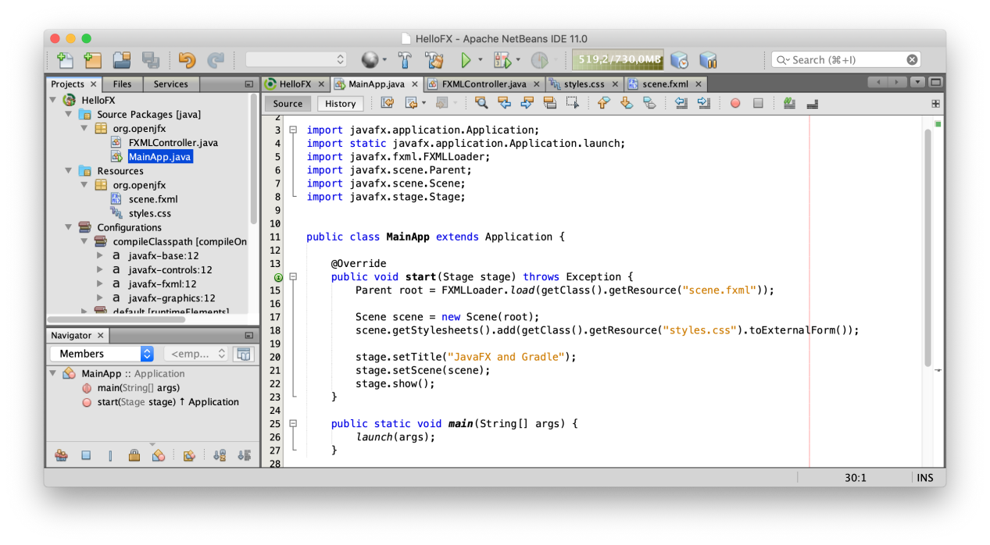

##### 4. Run the project

Select the build.gradle file and visualize the Navigator window. Build the project with Build -> build and click on Application -> run to execute the project.

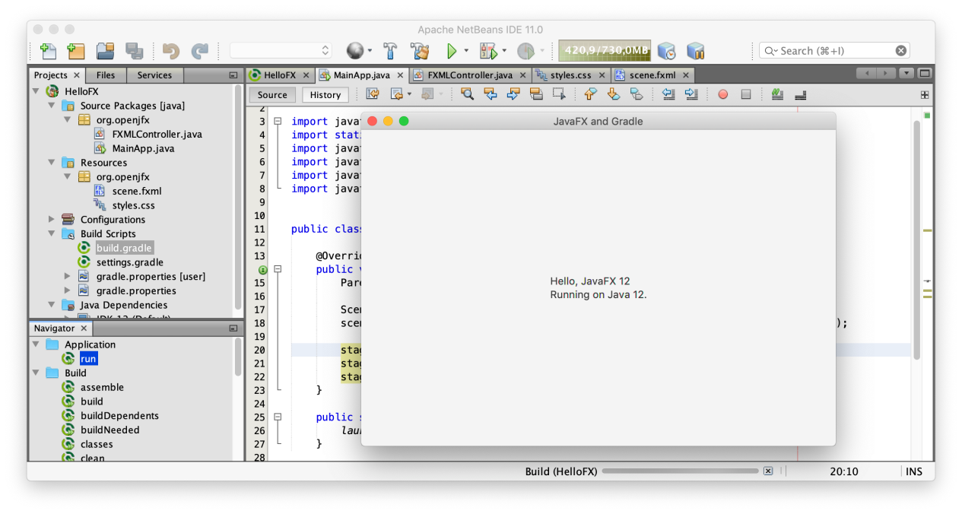

You can also open a terminal and run:

* [Linux/Mac](https://openjfx.io/openjfx-docs/" \l "nix-env)

./gradlew run

* [Windows](https://openjfx.io/openjfx-docs/" \l "win-env)

gradlew run

### Modular projects

Download the appropriate [JavaFX jmods](https://gluonhq.com/products/javafx/" \t "https://openjfx.io/openjfx-docs/_blank) for your operating system and unzip it to a desired location, for instance/Users/your-user/Downloads/javafx-jmods-12.

#### IDE

Follow these steps to create a JavaFX modular project and use the IDE tools to build it and run it. Alternatively, you can download a similar project from [here](https://github.com/openjfx/samples/blob/master/IDE/NetBeans/Modular/Java" \t "https://openjfx.io/openjfx-docs/_blank).

##### 1. Create a Java modular project

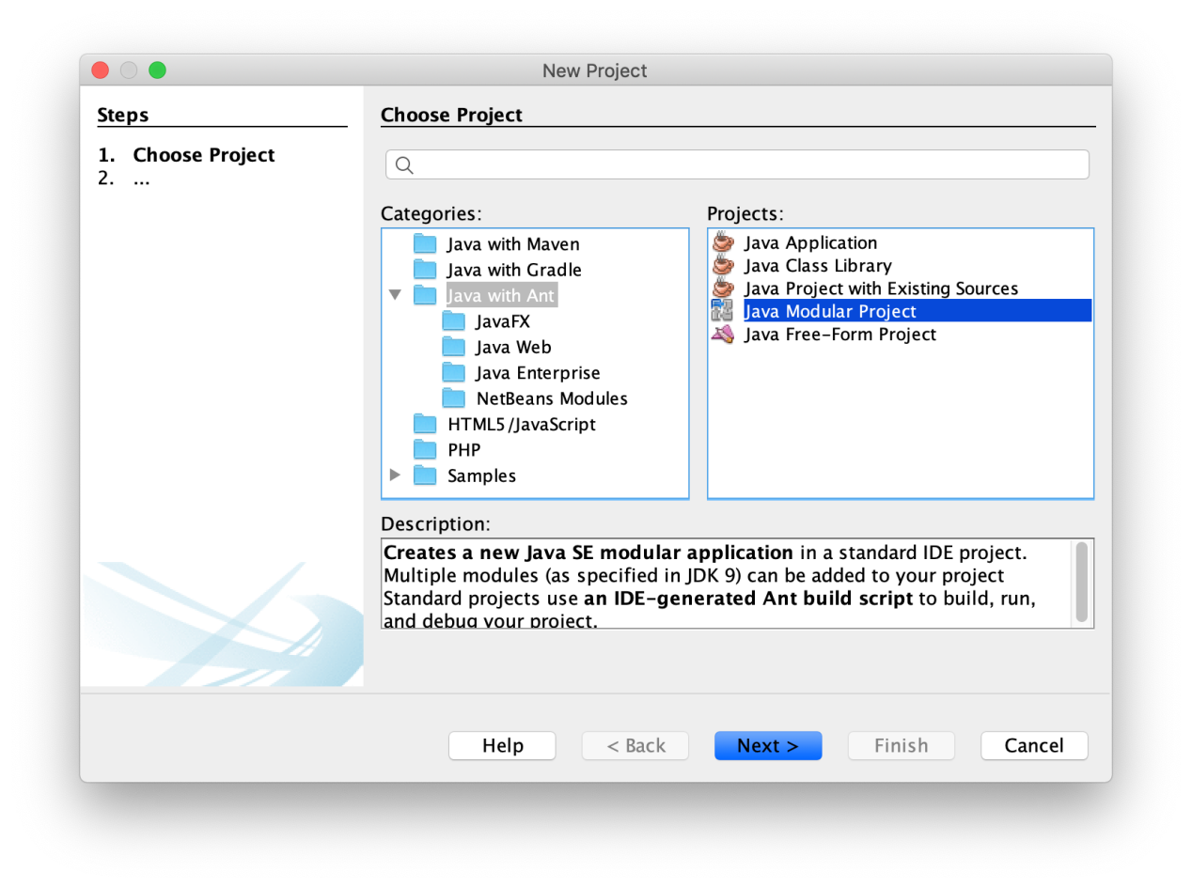

Provide a name to the project, like HelloFX, and a location. Select also platform JDK 12. When the project opens, right click on it and add New -> Module..., named it hellofx.

##### 2. Add JavaFX12

As explained for Non-modular projects, define the JavaFX12 library, if you haven't done it already.

Go to Properties -> Libraries -> Compile -> Module-path -> + -> Add Library  and add the JavaFX12library.

##### 3. Edit the module-info class

Edit the module-info class and include the required modules javafx.controls and javafx.fxml. Since FXML uses reflection to access the controller in the module, this has to be opened to javafx.fxml. Finally, export the package org.openjfx.

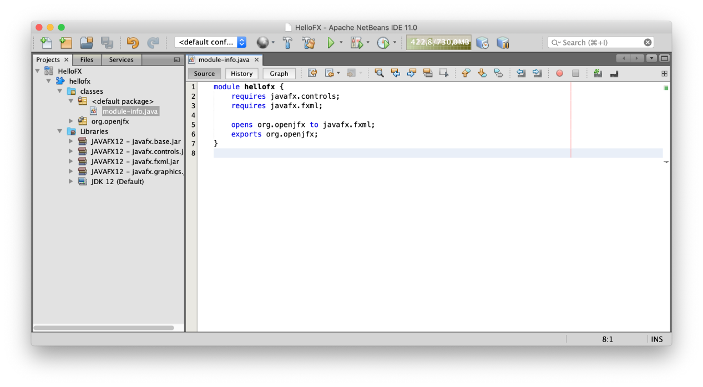

##### 4. Add the source code

Based on this [MainApp](https://github.com/openjfx/samples/blob/master/IDE/NetBeans/Modular/Java/HelloFX/src/hellofx/classes/org/openjfx/MainApp.java" \t "https://openjfx.io/openjfx-docs/_blank) class, add its content to the project main class. Then add the [controller](https://github.com/openjfx/samples/blob/master/IDE/NetBeans/Modular/Java/HelloFX/src/hellofx/classes/org/openjfx/FXMLController.java" \t "https://openjfx.io/openjfx-docs/_blank) and the [FXML](https://github.com/openjfx/samples/blob/master/IDE/NetBeans/Modular/Java/HelloFX/src/hellofx/classes/org/openjfx/scene.fxml" \t "https://openjfx.io/openjfx-docs/_blank) and and the [css](https://github.com/openjfx/samples/blob/master/IDE/NetBeans/Modular/Java/HelloFX/src/hellofx/classes/org/openjfx/styles.css" \t "https://openjfx.io/openjfx-docs/_blank) files.

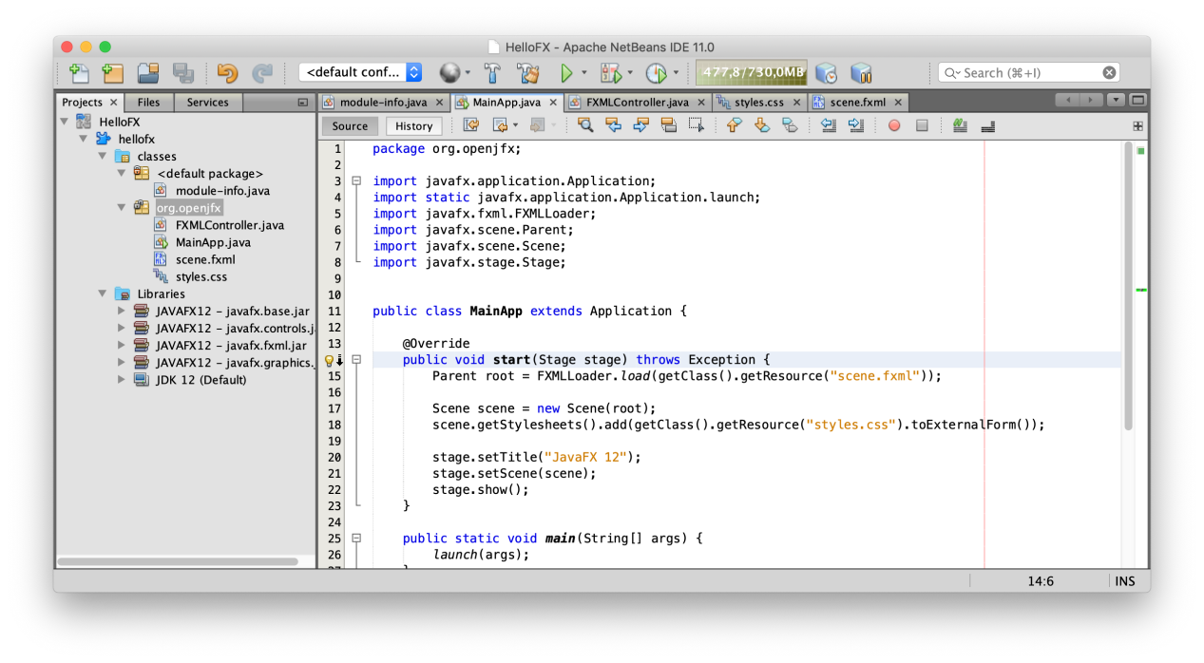

##### 5. Run the project

Being a modular project, and since we already added the JavaFX12 library to the module-path, there is no need to add any VM arguments. Click Run -> Run... to run the project.

##### 6. Create a custom runtime image

To create a runtime image, create a global Library under NetBeans -> Tools -> Libraries -> New Library. Name it JavaFXMODS12 and include the folder with the JavaFX jmods 12.0.1. Add this library to NetBeans -> Properties -> Libraries -> Run -> Modulepath and place it on top.

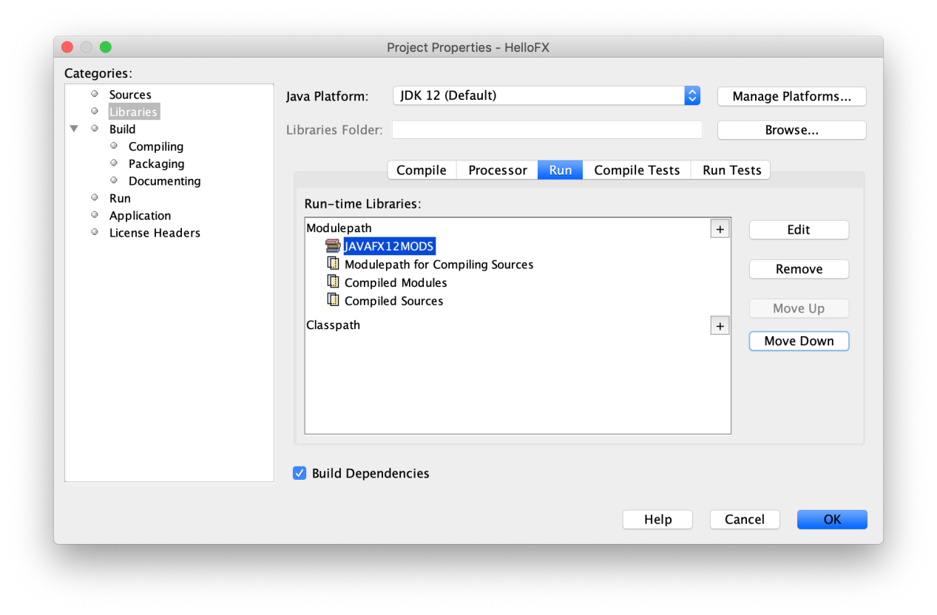

To create the custom runtime image now, go to NetBeans -> Properties -> Build -> Packaging and select Create JLINK distribution, providing a name for the launcher, like HelloFX.

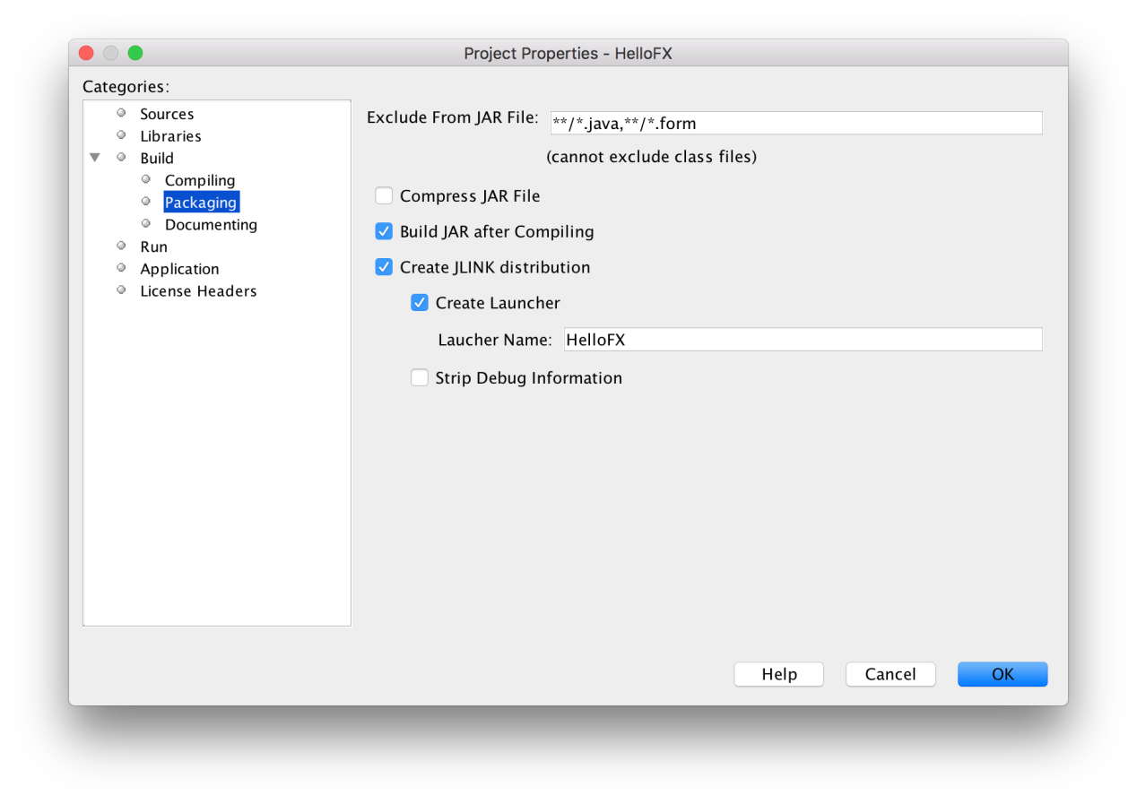

Apply and close the dialog, and click the Clean and Build button, to build the image.

To run the image:

* [Linux/Mac](https://openjfx.io/openjfx-docs/" \l "nix-env)

dist/jlink/HelloFX/bin/HelloFX

* [Windows](https://openjfx.io/openjfx-docs/" \l "win-env)

dist\jlink\HelloFX\bin\HelloFX

dist\jlink\HelloFX\bin\HelloFX

#### Maven

Follow these steps to create a JavaFX modular project and use the Maven tools to build it and run it. Alternatively, you can download a similar project from [here](https://github.com/openjfx/samples/blob/master/IDE/NetBeans/Modular/Maven" \t "https://openjfx.io/openjfx-docs/_blank).

##### 1. Create a Maven project

You can select the Java with Maven -> Project from Archetype project.



Look for org.openjfx in the search field and select the archetype, between javafx-archetype-fxml or javafx-archetype-simple, based on the use of FXML or not in your project.



Provide the name of the project, like HelloFX and a location. Provide the groupId, like org.openjfx, the package name, like org.openjfx.hellofx.



Click finish and the project will be created and opened.

##### 2. Verify the pom

You can find the generated pom file [here](https://github.com/openjfx/samples/blob/master/IDE/NetBeans/Modular/Maven/hellofx/pom.xml" \t "https://openjfx.io/openjfx-docs/_blank).

Verify it includes the javafx.controls and javafx.fxml dependencies, update their version to 12.0.1, and verify it includes the javafx-maven-plugin. Note that Maven manages the required dependencies: it will add javafx.baseand javafx.graphics that are required by javafx.controls and javafx.fxml, but most important, it will add the required classifier based on your platform, downloading the specific platform jars. As for any other maven dependencies, these jars can be found in the local .m2 repository.

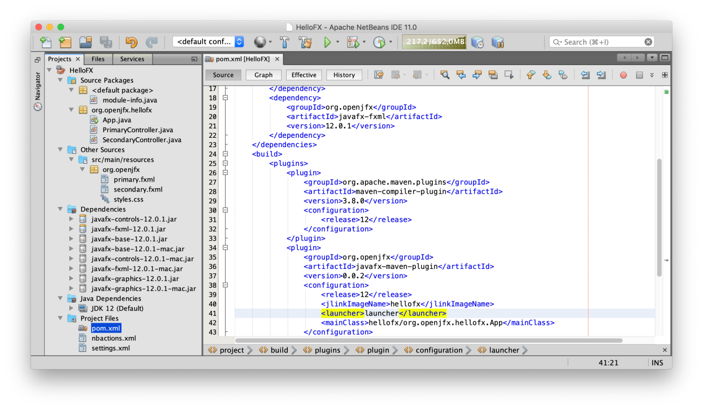

##### 3. Run the project

Before running the project from the Run button, we need to instruct NetBeans to use the javafx plugin instead of the default one. For that, go to Properties -> Actions -> Run project and change the Execute Goals with this:

clean javafx:run

Remove the default Set properties and click OK.



A nbactions.xml file will be created with this configuration.

Click Run -> Run Project to run the project.

****Note:****In case JAVA_HOME is not set to 12, running the project might fail. To avoid it, you can add the correct java command to the javafx-maven-plugin: <configuration><executable>/path/to/jdk-12/bin/java</executable></configuration>.

You can also open a terminal and run mvn clean javafx:run to run the project.

##### 6. Create a custom runtime image

To create a runtime image, run the following commands:

To create a custom runtime, run from a terminal with JAVA_HOME set to 12:

mvn clean javafx:jlink

Note the plugin allows the usual options as the jlink command, as well as creating a launcher or a zip with the custom image.

And after the image is built, you can run it from command line:

* [Linux/Mac](https://openjfx.io/openjfx-docs/" \l "nix-env)

target/hellofx/bin/launcher

* [Windows](https://openjfx.io/openjfx-docs/" \l "win-env)

target\hellofx\bin\launcher

#### Gradle

Follow these steps to create a JavaFX modular project and use the Gradle tools to build it and run it. Alternatively, you can download a similar project from [here](https://github.com/openjfx/samples/blob/master/IDE/NetBeans/Modular/Gradle" \t "https://openjfx.io/openjfx-docs/_blank).

##### 1. Create a Gradle project

****Note:****The built-in Gradle plugin doesn't support modular projects with external modular dependencies yet. You can either uninstall it or keep [NetBeans 10](https://netbeans.apache.org/download/nb100/nb100.html) installed, and then install the Gradle plugin for NetBeans 2.0.2, from the GitHub [repository](https://github.com/kelemen/netbeans-gradle-project/releases" \t "https://openjfx.io/openjfx-docs/_blank). Since the former requires administrator permissions and doesn't allow switching plugins easily, the latter is the recommended option.

Create a Gradle -> Single Gradle Project with Java.

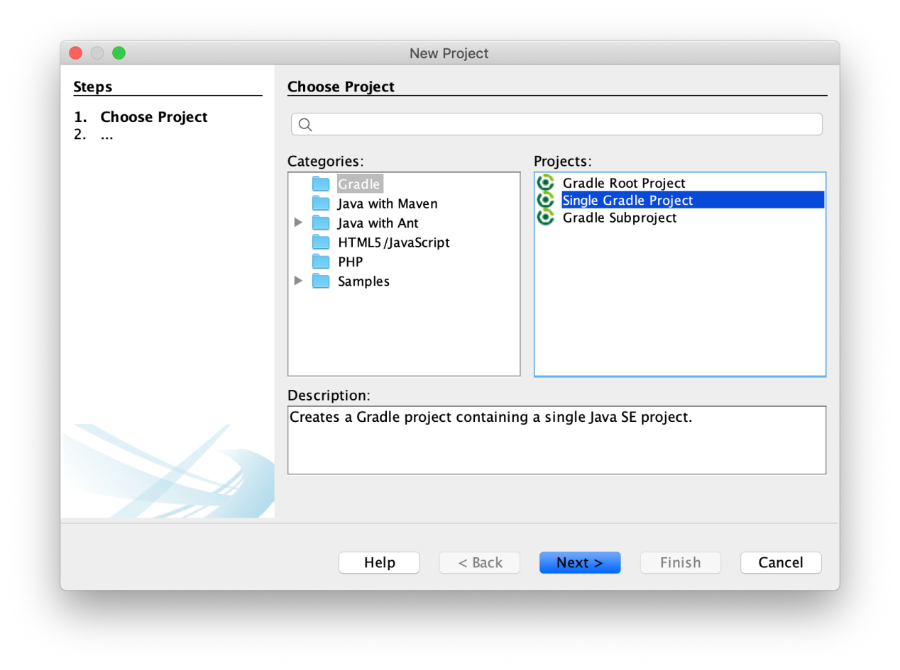

Then provide a name to the project, like HelloFX, a location for the project, and the main class name: org.openjfx.MainApp.

##### 2. Modify the build

Edit the build.gradle file and replace it with this [build](https://github.com/openjfx/samples/blob/master/IDE/NetBeans/Modular/Gradle/hellofx/build.gradle" \t "https://openjfx.io/openjfx-docs/_blank) file.

Note the use of the org.openjfx.javafxplugin plugin, that removes the necessity of adding the JavaFX dependencies and setting the module-path for the compile and run task for them.

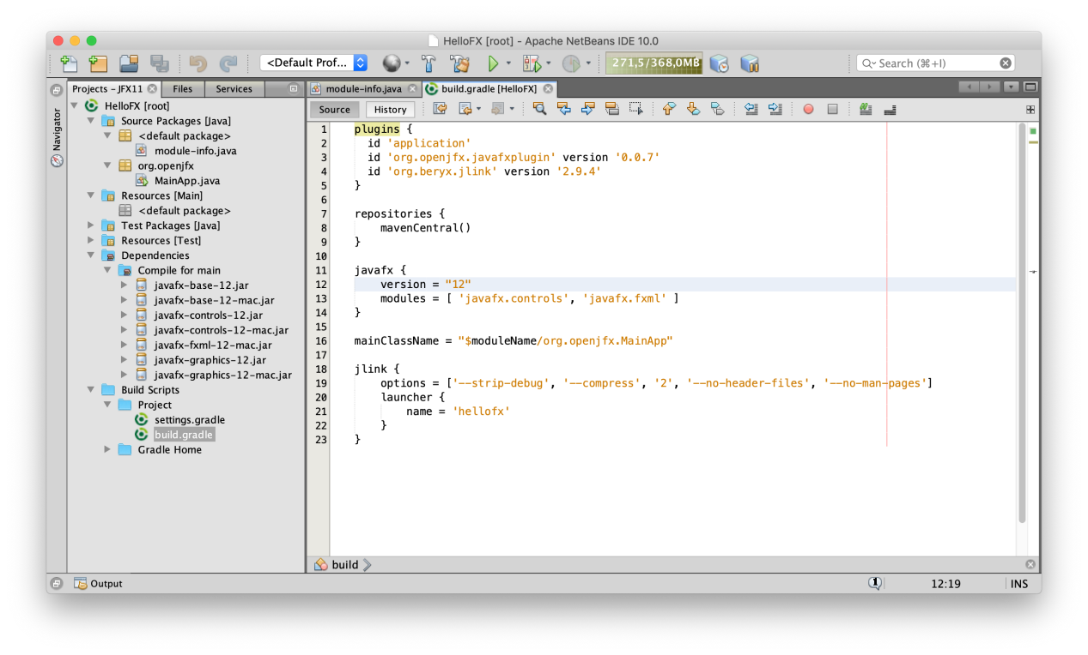

##### 3. Add the module-info class

Add the module-info class, including the required modules javafx.controls and javafx.fxml. Since FXML uses reflection to access the controller in the module, this has to be opened to javafx.fxml. Finally, export the package org.openjfx.

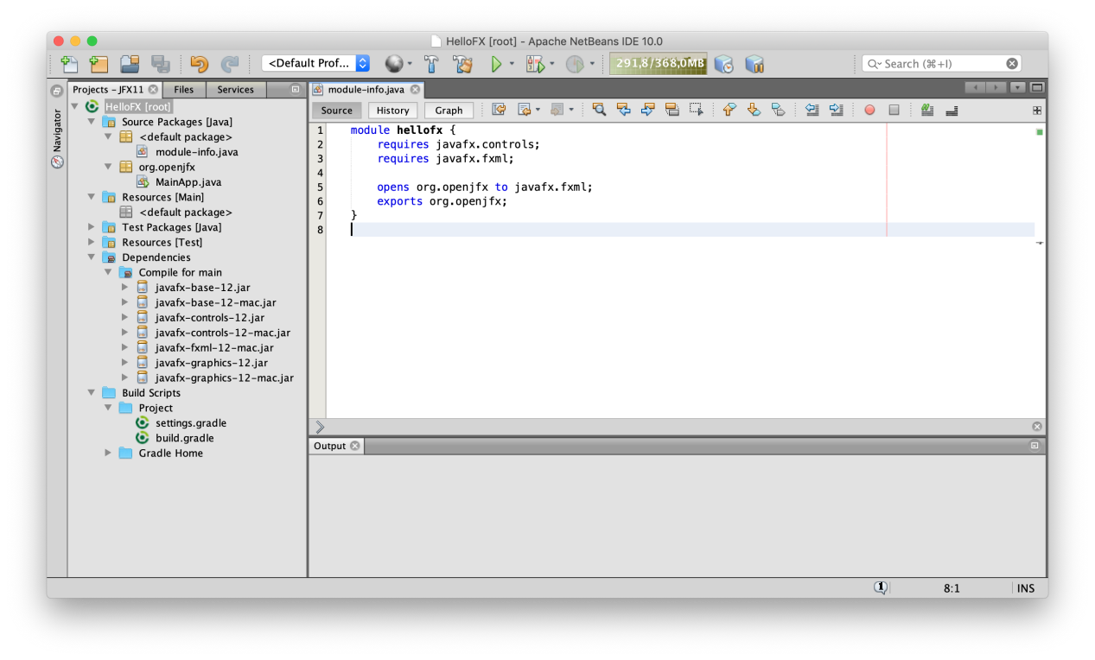

Reload the project to take into account all the changes in the gradle project.

##### 4. Add the source code

Based on this [MainApp](https://github.com/openjfx/samples/blob/master/IDE/NetBeans/Modular/Gradle/hellofx/src/main/java/org/openjfx/MainApp.java" \t "https://openjfx.io/openjfx-docs/_blank) class, add its content to the project main class. Then add the [controller](https://github.com/openjfx/samples/blob/master/IDE/NetBeans/Modular/Gradle/hellofx/src/main/java/org/openjfx/FXMLController.java" \t "https://openjfx.io/openjfx-docs/_blank) and the [FXML](https://github.com/openjfx/samples/blob/master/IDE/NetBeans/Modular/Gradle/hellofx/src/main/resources/org/openjfx/scene.fxml" \t "https://openjfx.io/openjfx-docs/_blank) and the [css](https://github.com/openjfx/samples/blob/master/IDE/NetBeans/Modular/Gradle/hellofx/src/main/resources/org/openjfx/styles.css" \t "https://openjfx.io/openjfx-docs/_blank) files.

##### 5. Run the project

Right click on the project window, select Tasks -> build -> build to build the project, and on Tasks -> run -> run to execute the project. You can also open a terminal and run:

* [Linux/Mac](https://openjfx.io/openjfx-docs/" \l "nix-env)

./gradlew run

* [Windows](https://openjfx.io/openjfx-docs/" \l "win-env)

gradlew run

##### 6. Create a custom runtime image

To create a custom runtime, you can use the [org.beryx.jlink](https://badass-jlink-plugin.beryx.org/releases/latest/" \t "https://openjfx.io/openjfx-docs/_blank) plugin. It can be easily combined with the JavaFX Gradle plugin:

plugins {

id 'application'

id 'org.openjfx.javafxplugin' version '0.0.7'

id 'org.beryx.jlink' version '2.10.2'

}

javafx {

version = "12.0.1"

modules = [ 'javafx.controls', 'javafx.fxml' ]

}

jlink {

launcher {

name = 'hellofx'

}

}

to generate the custom image. Right click on the project window, select Tasks -> jlink -> jlink task to create the image.

To run the image, run from a terminal:

* [Linux/Mac](https://openjfx.io/openjfx-docs/" \l "nix-env)

build/image/bin/hellofx

* [Windows](https://openjfx.io/openjfx-docs/" \l "win-env)

Build\image\bin\hellofx